TRY OUT (TO) UJIAN NASIONAL

TAHUN PELAJARAN 2016 / 2017

DINAS PENDIDIKAN PROVINSI DKI JAKARTA

KODE  SOAL | B02
MATA PELAJARAN : BAHASA INGGRIS
KELAS : XII
PROGRAM STUDI : MIPA / IPS
HARI,TANGGAL :
WAKTU : (120 menit)

PETUNJUK UMUM

- Isikan nomor ujian, nama peserta, mata pelajaran, dan tanda tangan peserta pada Lembar Jawaban Ujian Komputer (LJUK), sesuai petunjuk di LJUK
- Hitamkan bulatan di depan nama mata ujian pada LJUK.
- Tersedia waktu 120 menit untuk mengerjakan paket tes tersebut.
- Jumlah Soal sebanyak 50 pilihan ganda.
- Periksa dan bacalah soal-soal sebelum Anda menjawabnya.
- Laporkan kepada pengawas ujian apabila terdapat lembar soal yang kurang jelas, rusak, atau tidak lengkap.
- Tidak diizinkan menggunakan HP, kamus, atau alat komunikasi lainnya
- Periksalah dahulu pekerjaan Anda sebelum diserahkan kepada pengawas Ujian

PETUNJUK KHUSUS

      - Pilihlah satu jawaban yang paling tepat dengan menghitamkan secara penuh bulatan jawaban Anda, dengan menggunakan pensil 2B.

Contoh menjawab :

a  b  c  d  e | Salah | a  b  c  d  e | salah
a  b  c  d  e | Salah | a  b  c  d  e | benar
.

      - Apabila Anda ingin memperbaiki/mengganti jawaban, bersihkan jawaban semula dengan karet penghapus hingga bersih, kemudian bulatkan pilihan jawaban yang Anda anggap benar.

SELAMAT BEKERJA

LISTENING SECTION
In this section of the test, you will have the opportunity to show how well you understand spoken English. There are four parts to this section with special instructions for each part.

Part I
Questions: 1 to 4
Instructions:
In this part of the test, you will hear some dialogues and questions spoken in English. The questions and the dialogues will be repeated twice. They will not beprinted in your test book, so you must listen carefully to understand what the speakers are saying.

After you listen to the dialogue and the question, read the five possible answers, then decide which one would be the best answer to the question you have heard.
Now listen to a sample question!

You will hear:
Man : I don’t know what to order. I could drink everything on the menu.
Woman : Why don’t you try guava juice, orange juice or ice tea?
Man : Guava juice sounds good.
Woman : I think I’ll have a big glass of cola float.

Narrator : What will the woman order?
- Guava juice.
- Orange juice.
- Ice tea.
- Cola float.
- Mineral water.

The best answer to the question “What will the woman order?” is cola float.
Therefore, you should choose answer (D)

Sample answer:

A B C D E

1.
- The man.
- Her sister.
- Her grandma.
- The designer.
- She herself.

2.
- The man’s new store.
- Thanking someone.
- Selling 400 items.
- This week’s sales.
- Popular topic.

3.
- Go out in the evening.
- See a romantic film.
- WatchFurious 7
- Pick her up at 6.30.
- Enjoy a romantic film with her.

4.
- The man enjoyed watching the film.
- The ending of the film is easily known.
- The film they watched was unexpected.
- The man watched the film in the bedroom
- The man and the woman do not like each other

Part II
Questions: 5 to 7
Directions:
In this part of the test, you will hear several questions or statements spoken in English followed by four responses, also spoken in English. The questions and responses will be spoken twice. They will not be printed in your test book, so you must listen carefully to understand what the speakers are saying. You have to choose the best response to each question or statement.
Now listen to a sample question:
You will hear:
Man : You look uncomfortable.
Woman : It’s very hot here.
Woman : I’ll switch on the fan for you.
Man :

You will also hear:
- I’ll be glad.
- I’ll be happy.
- Thank you.
- It’ll be okay.

Narrator: What is the best response to the woman’s statement?
The best response to the woman’s statement “I’ll switch on the fan for you.” is ” (Thank you.) Therefore, you should answer Choice “C”.

- Mark your answer on your answer sheet.
- Mark your answer on your answer sheet.
- Mark your answer on your answer sheet.
Part III
Questions 8 to 11
Directions:
In this part of the test you will hear some dialogues or monologues spoken in English. The dialogues or monologues will be spoken twice. They will not be printed in your test book, so you must listen carefully to understand what the speakers are saying. After you listen to the dialogue or monologue, look at the five pictures provided in your test book, and decide which one would be the most suitable one with the dialogue or monologue you have just heard.

 | A |  | B | 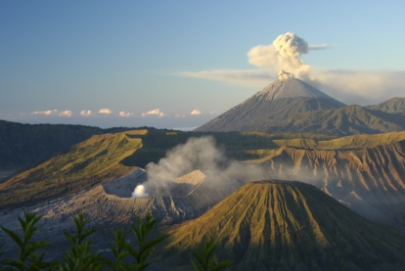 | C | 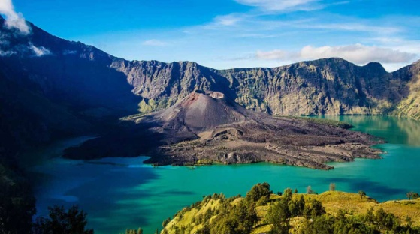
 | D | 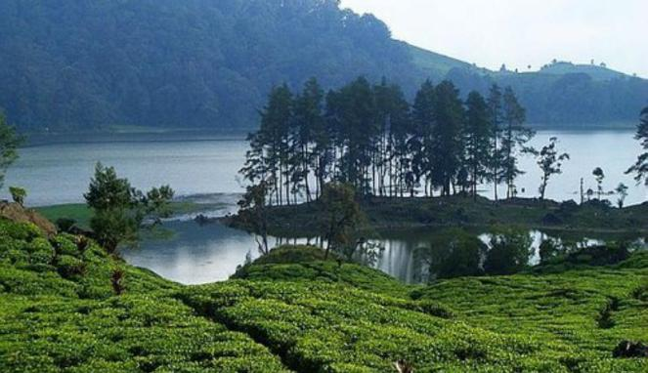 | E | 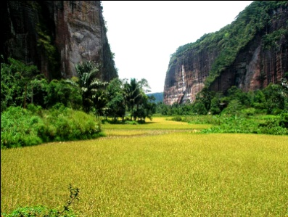

 | A | 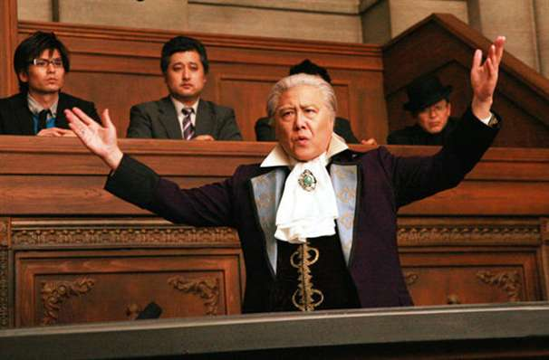 | B |  | C
 | D |  | E | 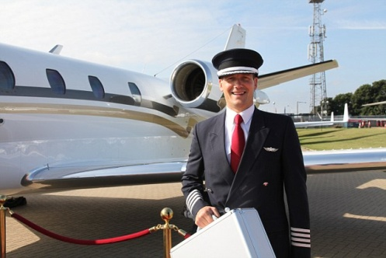

 | A | 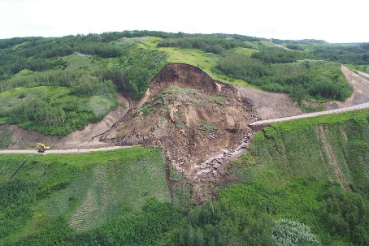 | B |  | C | 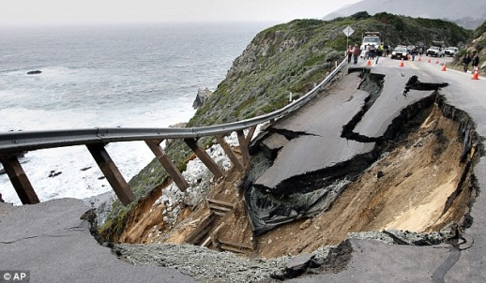
 | D | 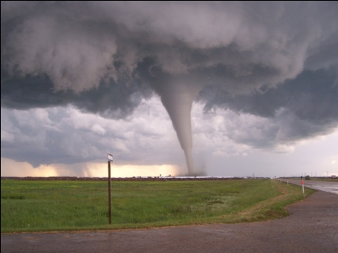 | E | 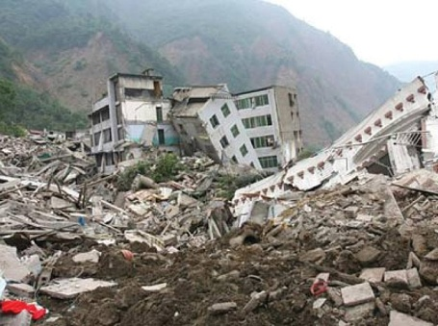
 | A | 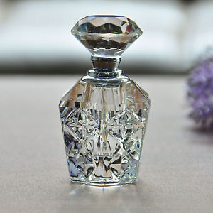 | B | 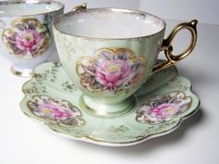 | C | 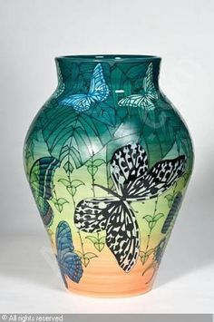
 | D | 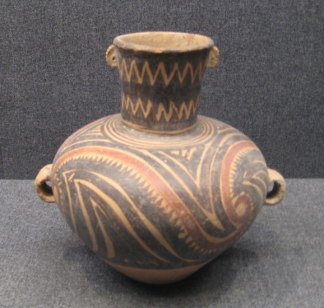 | E | 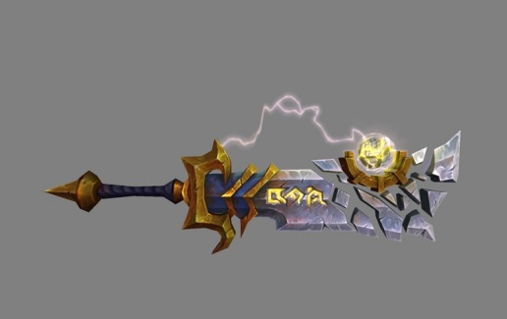

12. A. The presence of Middle Eastern investors.
- The demand for Islamic REITs in Indonesia.
- Middle Eastern investors to invest in property.
- Islamic REITs to attract Middle East investors.
- The interest of Takaful companies to invest in the REITs.

13. A. They have no sharia agreement.
- They are not working on the rule.
- They were not interested in investing.
- No Middle Eastern investors got involved.
- The companies need medium-term investment.

14. A. In 1970.
- In 1971.
- In 1973.
- In 1978.
- In 1983.

- A. He thought up the handheld mobile phone.
- He imagined a hand phone like the car phone.
- He brought the first handheld cellular phone to market.
- He introduced the first handheld cellular phone call to pubic.
- He and his team conceived the idea of the first handheld mobile phone.

This is the end of listening section.

The Following text is for questions no 16 and 17

To all 10th grade students,
Please join one or two of extracurricular activities offered by the school below:

Scouts - Saturday - 15.00 - 17.30 - School yard
Badminton - Tuesday - 15.30 - 16.30 - School Gymnasium
Volleyball - Friday - 15.00 - 16.30 - School yard
Basketball - Wednesday - 15.00 - 16.30 - School yard
Dancing – Tuesday - 15.30 - 16.30 - School hall
English Club – Monday - 15.00-17.00 - School hall

See your class captain for register!

Student Organization Supervisor,
Miss Anindya

- The text mainly tells about ….
- the instruction to see the class captain.
- the places where extracurricular activities are held.
- the announcement to join extracurricular activities.
- the invitation from Student Organization Supervisor.
- the information about time for extracurricular activities.

- After reading the text, we can conclude that …
- there are seven extracurricular activities offered by the school.
- the students can only join one extracurricular activity.
- the students should see Miss Anindya for registration.
- each extracurricular activity has two hours’ duration.
- there is no extracurricular activity on Thursday.

The Following text is for questions no 18 and 19

Sector 17
Vashi
New Bombay
6th January, 2017
Dear Maya,
Thank you very much for your last letter. It was great to hear from you after so many months. You seem to be having a nice time in France.

Thanks for the photograph. I absolutely loved that snap of your standing in front of the Eiffel Tower. France looks stunning. Someday, I would definitely like to go there.

There’s not much happening here. I am busy with my works and kids.

By the way, are you coming home anytime soon? If you are, let me know the dates and we can arrange to meet up.

Hope to see you soon!

Aditi

- What did Aditi think when she saw Maya's photo in front of Eiffel Tower?
- She loved France very much
- She would like to visit France someday
- She planned to take her children to France
- She wanted to meet Maya in front of Eiffel Tower
- She and Maya would have a picture in Eiffel Tower

- We can imply that Maya and Aditi are ....
- sisters
- friends
- cousins
- siblings
- associates

The Following text is for questions no 20 and 22

Born and raised in Queens, New York City, Donald Trump received an economics degree from the Wharton School of the University of Pennsylvania in 1968. In 1971, he took charge of his family's real estate and construction firm, Elizabeth Trump & Son, which was later renamed The Trump Organization. During his business career, Trump has built, renovated, and managed numerous office towers, hotels, casinos, and golf courses. He owned the Miss USA and Miss Universe pageants from 1996 to 2015, and has lent the use of his name in the branding of various products. From 2004 to 2015, he hosted The Apprentice, a reality television series on NBC. As of 2016, Forbes listed him as the 324th wealthiest person in the world and 113th richest in the United States, with a net worth of $4.5 billion.
Trump sought the Reform Party's presidential nomination in 2000, but withdrew before voting began. He considered running as a Republican for the 2012 election, but ultimately decided against it. In June 2015, he announced his candidacy for the 2016 election, and quickly emerged as the front-runner among 17 contenders in the Republican primaries. His final opponents suspended their campaigns in May 2016, and in July he was formally nominated at the Republican Convention along with Mike Pence as his running mate. His campaign received unprecedented media coverage and international attention. Many of his statements in interviews, on social media, and at campaign rallies were controversial or false.
Trump won the presidential election on November 8, 2016, against Democratic rival Hillary Clinton, and assumed office on January 20, 2017. Elected at age 70, he is the oldest and wealthiest person to assume the presidency; the first without prior military or governmental service; and the fifth elected with less than a plurality of the national popular vote.
(https://en.wikipedia.org/wiki/Donald_Trump)

- What is the writer's intention in writing the text?
- Telling about American's election
- Sharing about Donald Trump's real estatefirm
- Describing Donald Trump who won the election
- Explaining about political view of Donald Trump
- Admiring Donald Trump from his life achievement

- Why did Donald Trump campaign get unprecedented media coverage?
- Many of his statements were controversial.
- He owned the Miss USA and Miss Universe pageants.
- Trump's platform emphasized renegotiating U.S.–China relations.
- His campaign rallies showed his mocking expression to some people.
- He advocates a largely non-interventionist approach to foreign policy.

- His campaign received unprecedented media coverage and international attention.
The underlined word has the similar meaning to ....
- ordinary
- common
- greatest
- worst
- large

The Following text is for questions no 23 – 25

By looking at the name “Blender”, we might be able to guess the function of this electronic device. We put things inside the blender in order to “blend it” or “mix it”. If you never use a blender before, you may need to read this following procedure of how to operate a blender.

1. Prepare the ingredients that you want to mix. The ingredients can be vary, but mostly people use blender for these following things: Ice, vegetables, fruits, milk, or any kind of food and drinks.
2. Cut the ingredients into smaller pieces if the ingredients were solid and big.
3. Prepare the blender cup, make sure to clean it before we use it and put the blender blades on the bottom of the cup.
4. Place the blender cup on the blender machine.
5. Insert the plug into the electricity socket.
6. Put all of the ingredients into the blender cup.
7. Add some water to help the blender mix the ingredients evenly.
8. Close the lid and cover the blender cup tightly.
9. Start the blender by pressing the speed button; you can start from the medium speed
10. Wait until we get the right texture of the mixture, we can adjust the speed and also add some more water if necessary.
11. Open the blender and pour the mixture into a glass or bowl.

- The text mainly talk about the procedure of ....
- opening the electronic machine “Blender”
- pressing the speed button of “Blender”
- operating the blender electronic device
- inserting the plug of the electricity socket
- starting the Blender machine from the medium speed

- What can you do to get the right texture and mixture?
- Adjust the speed and add some more water
- Start from medium speed after that adjust the speed
- Cut the ingredient into small pieces and adjust the speed
- Cut the ingredient into small pieces and add some more water
- Put all of the ingredients into the blender cup and adjust the speed

- Close the lid and cover the blender cup tightly.
The word lid has a similar meaning to ....
- dip
- top
- firm
- crown
- beneath

The Following text is for questions no 26 and 28

PETRUK CAVE

Petruk Cave is one of the leading tourist attractions in Kebumen, Central Java. The cave is located in Dukuh Mandayana Candirenggo village, Ayah District, Kebumen Regency. In the Petruk Cave there is no lighting that illuminates the cave. It is still very natural cave so that Petruk Cave is very dark to be entered. The name is taken from the Punokawan of puppet characters that is Petruk. The cave named Petruk cave because the length of it is like the petruk’s nose.
In the cave there are three floors, the first is a basic cave, Hindu cave and Petruk . The base cave is a short cave which is just 100 meters away. The cave is used for tourist attractions. Hindu cave is part of the cave that is usually used to put offerings to the ancestor. Inside Petruk there are so many stalactites and stalagmites which are really awesome. If you want to explore this cave, you must be led by guides who are ready to take you through the cave. After arriving at the end of the cave, you can see the beach or waterfall located near the end of the cave.

- The purpose of the text isto ….
- inform about tourism in Kebumen
- tell the readers about Petruk cave
- explain how to get to Petruk cave
- acknowledge Petruk Cave
- promote Petruk Cave

- What makes Petruk cave worth to visit?
- It is not far from the beach and waterfall.
- It has so many stalactites and stalagmites.
- The cave’s depth is as deep as Petruk’s nose
- It is the place to put offerings to the ancestor.
- It’s length is the similar form as Petruk’s nose

- In the Petruk Cave there is no lighting that illuminates the cave.
The underlined word means ....
- lights
- raises
- clarifies
- darkens
- explains

The Following text is for questions no 20 and 22

Town Contaminated

Moscow – A Russian journalist has uncovered evidence of another Soviet nuclear catastrophe, which killed 10 sailors and contaminated an entire town.

Yelena Vazrshavskya is the first journalist to speak to people who witnessed the explosion of a nuclear submarine at the naval base of Shkotovo – 22 near Vladivostock.

The accident, which occurred 13 months before the Chernobyl disaster, spread radioactive fallsout over the base and nearby town, but was covered up by officials of the Soviet Union. Residents were told the explosion in the reactor of the Victor class submarine during a refit had been a ‘thermal’ and not a nuclear explosion. And those involved in the cleanup operation to remove than 600 tons of contaminated material were sworn to secrecy.

A board of investigators was later to describe it as the worst accident in the history of the Soviet Navy.

- What is the text tells us about?
- The first journalist interviewed the people about the explosion of nuclear submarine.
- Soviet nuclear catastrophe which killed 10 sailors and contaminated the entire town.
- The reactor of the victor-class submarine had been a thermal.
- Radioactive falls out over the base and nearby town.
- The worst accident in the history of the Soviet Navy.

- What is the effect of Soviet nuclear catastrophe?
- Covered up by the officials of the Soviet Union
- Contaminated entire town and killed 10 sailors
- Described as the worst accident in the Soviet Navy
- Removed more than 600 tons contaminated material
- Spread radioactive fell out over the base and nearby town

- “......, but was covered up by officials of the Soviet Union.
The underlined wordsmeans...
- hidden
- packed
- blocked
- included
- protected

The Following text is for questions no 32 - 34

King Dan – the legend of Denmark
The story is told that, in olden days, there were three brothers: Dan, Nor and Østen. They were the sons of King Ypper, who lived in Uppsala in Sweden, which was named for him.
The brothers went their separate ways, settling each in a different country. Dan went to Denmark, Nor to Norway, and Østen stayed in Sweden, in the countries to the East.
At that time, the realm of Denmark did not yet exist. Dan ruled only over the island of Zealand and the lesser isles. Jutland, Funen and Scania were each separate kingdoms. The Jutes were, at that time, at war with the German king. They built up earthworks and a palisade along their southern border, in that place where Queen Thyra later caused Dannevirke to be built. They named this wall Kovirke. But, when the German king came with a mighty host, they sent messengers to King Dan asking for his help.
Dan went to war with the Germans, and a great battle was fought before the wall. Most of the enemy fell, “biting the grass”, as the saying goes, and the rest fled. When the Jutes saw how brave King Dan was, they led him to their thing-place, and placed him upon a great stone, proclaiming him their king. This stone was since called Daneryge (ryge being a Jutish word for “large stone”), and it was there, later, that Danish kings were acclaimed. Daneryge was to be found on the thing-place outside Viborg, and the entire place has also been called Danerlyngen.
When the people of Funen and Scania heard of this, they also elected Dan their king. Dan now summoned the best men in all the realm, and he said to them: “This land is fair and fertile, yet it has one flaw: it lacks for a name.”
They answered him: “You are Dan, and therefore the realm shall be called Danmark, and this name shall last for so long as the world lasts.”
King Dan built himself a royal palace at Lejre near Roskilde Fjord. He was called Dan the Grand or the Mighty, because no man before him had had such a great domain. After his death, the Danes built a barrow. They placed him in the tomb chamber fully armed and arrayed for war, mounted on his horse.

- Based on the text, which kingdoms were acclaimed under King Dan?
- Jutland, Funen, Scania, Lejre
- Zealand, Jutland, Funen, Scania
- Kovirke, Norway, Sweden, Jutes
- Lejre, Daneryge, Zealand, Kovirke
- Zealand, Norway, Sweden, Jutland

- What is the main idea of paragraph 4?
- The Jutes built a large stone called Daneryge
- The Funen and Scania elected Dan their King
- King Dan honored himself with a great royal palace
- Because of his bravery, Danish king were acclaimed on Daneryge
- A great war happened before the Kovirke wall between Funen and German

- The moral value of the text is ....
- diligence is the mother of good fortune.
- we should not put our eggs in one basket.
- when the going gets tough, the tough gets going.
- we should not put off till tomorrow what we can to today.
- diseases of the soul are more dangerous than those of the body.

- “This land is fair and fertile ... it has one flaw”
- though
- either
- but
- and
- so

The Following text is for questions no 36 - 38

When I was 2nd grade of senior high school, my friends and I went to Bali. We were there for three days. I had many impressive experiences during the vacation.
First day, we visited Sanur Beach in the morning. We saw the beautiful sunrise together. It was a great scenery. Then, we checked in to the hotel. After prepared ourselves, we went to Tanah Lot. We met so many other tourists there. They were not only domestic but also foreign tourists.
Second day, we enjoyed the day on Tanjung Benoa beach. We played so many water sports such as banana boat, jet sky, speedboat etc. We also went to Penyu island to see many unique animals. They were turtles, snakes, and sea birds. We were very happy. In the afternoon, we went to Kuta Beach to see the amazing sunset and enjoyed the beautiful wave.
The last day, we spent our time in Sangeh. We could enjoy the green and shady forest. There were so many monkeys. They were so tame but sometimes they could be naughty. We could make a close interaction with them. After that, we went to Sukowati market for shopping. That was my lovely time. I bought some Bali T-Shirt and souvenirs.
In the evening, we had to check out from the hotel. We went back home bringing so many amazing memories of Bali.

- What does the text tell about?
- The writer visited Bali
- The writer played many water sports
- The writer and his/her friends visited Bali
- The writer and his/her friends visited Tanjung Benoa
- The writer and his/her friends visited Bali for three days

- How did they enjoy the Tanjung Benoa Beach?
- By diving the sea
- By enjoying the sunset
- By going to Penyu island
- By playing many water sports
- By enjoying the beautiful wave

- ... we enjoyed Bali for 3 days, we went home bringing so many amazing memories of Bali.
- When
- After
- Then
- While
- Because

The Following text is for questions no 39 - 42

SINGAPORE: Changi Airport recorded an all-time high of 58.7 million passengers in 2016, a growth of 5.9 per cent on 2015, Changi Airport Group announced in a statement on Monday (Jan 30).

Aircraft movements rose 4.1 per cent for the year to 360,490, while airfreight throughput increased by 6.3 per cent to hit a new high of 1.97 million tons.

The airport saw its busiest day in its history on Dec 23, 2016, with 202,359 passengers passing through its gates. For the month of December alone, Changi handled a total of 5.68 million passengers, up 7.2 per cent from 2015.

Routes to Southeast Asia, Northeast Asia and Oceania contributed 90 per cent of the growth in passenger traffic in 2016. China moved from fifth to become Changi Airport’s third largest country market for the year, a growth of 15 per cent.

Visitor arrivals from Thailand and Vietnam also grew in 2016, up 6 per cent and 8 per cent respectively from 2015.

Jakarta remained as Changi’s busiest route in 2016, followed by Kuala Lumpur and Bangkok. New destinations included: Amritsar and Jaipur in India, Urumqi in China, the Australian capital Canberra, Wellington in New Zealand, Nadi in Fiji, Sapporo in Japan and Dusseldorf in Germany.

“Despite a backdrop of economic and socio-political uncertainties, we maintain a positive outlook for the year ahead,” said Changi Airport Group CEO Lee SeowHiang. “We see opportunities in emerging markets within Africa and Eastern Europe.

“At the same time, we will continue to grow our long haul routes to Western Europe, and strengthen our connectivity within the region to secondary cities in South East Asia, China and India.”

Changi Airport is the world's sixth busiest for international traffic, based on 2015 figures, and is expected to open its fourth terminal later this year.

- CNA/rw
http://www.channelnewsasia.com/news/singapore/changi-airport-handled-record-58-7m-passengers-in-2016/3477488.html

- The news is about …..
- The contribution of each route influences the growth of passengers’ number
- Jakarta gives the biggest contribution on the growth of passengers’ number
- Changi Airport handled record 58.7m passengers in 2016
- Changi Airport maintain a positive outlook in 2016
- The movement of an aircraft

- How many passengers were recorded passing the gate at Changi’s Airport busiest day?
- 5.68 million passengers
- 58.7 million passengers
- 5.9 million passengers
- 340,690 passengers
- 202,359 passengers

- From the news above, we can say that Changi International Airport ….
- gave its best service in 2016
- recorded as the best airport in the world
- reached its’ highest passengers number in 2016
- became the sixth busiest airport in the world in 2016
- showed that it had never been complained before 2016

- “..., we will continue to grow our long haul routes to Western Europe, and strengthen our connectivity within the region to secondary cities in South East Asia, China and India.”
- Meanwhile
- Although
- However
- But
- Yet

The Following text is for questions no 43 - 46

The most traditional American food may well be cornmeal. Cornmeal, as we know it today, began as a Native American staple. The native Americans grew corn of six different colors- black, red, white, yellow, blue, and multicolored. They ground the corn kernels into cornmeal and mixed it with salt and water, then baked it. This recipe was introduced to the early colonists, who experimented with it and developed their own uses for cornmeal. Succotash (a meat stew with cornmeal added) and mush (leftover cornmeal porridge cut and fried) are two meals invented by early colonists.
Visitors can travel to the South and enjoy spoon bread, a smooth puddinglike dish, or to New England for johnnycakes, kind of flat pancake. But probably the most common forms of cornmeal nationwide are corn wide, cornbread, cornmeal muffins, and the “hush puppy”- a ball of cornmeal batter that is fried in oil.

- What is the text about?
- Originally Cornmeal
- Six different colorscornmeal
- The most common forms of cornmeal
- Cornmeal as traditional American food
- The colonist’s experimenton the uses of cornmeal.

- It can be inferred from the text that cornmeal was originally used by…
- Visitors
- Native Americans
- The early colonists
- The New Englanders
- The people in the South

- What does the second paragraph mainly talk about?
- A kind of flat pancake
- Where to find “Hush puppy”
- A smooth puddinglikedish
- A fried leftover form of a cornmeal dish
- various kinds of cornmeal that visitors can enjoy

- Cornmeal, as we know it today, began as a Native American staple.
The underlined word has the similar meaning to ....
- life style
- main food
- common product
- traditional recipe
- important product

The Following text is for questions no 47 - 50
Nowadays, internet has permeated virtually to every aspect of modern life. If you have access to an internet connection, you can get limitless amount of goods, services and entertainment. You can do just about anything online, including your banking and financial transactions. How comfortable and easy you can conduct your banking business in cyberspace.
You have 24 hours access for online banking. When your neighborhood bank has closed, you can still access your account and make transactions online. It is very convenient and easy. When you are in an emergency situation and you need to execute a banking transaction when the bank is closed, you just need an internet connection to do online banking transactions. You can access your account anywhere. If you are on a business trip or vacation and you need banking transactions, you can do online banking transactions without disturbing your business or vacation as long as the place has an internet network.
Online banking is generally faster than going to the bank. Using online banking transactions takes less time. You just click the features of the transactions which take a few minutes. With online banking, you can access your account instantly at your leisure. Long teller queues at the bank and traffic on the road are time consuming.
The features and services are available on online banking. You can apply for loans, check the progress of your investment, review interest rates and see important bank information.
Online banking is generally secure, but make sure that the website that you access has a valid security certificate. It protects you from cybercrime that is waiting to steal your personal and financial information.
Therefore, online banking is recommended for banking transactions for the convenience and ease, but make sure that the website you access has a valid security certificate.

- The topic of the text is …
- the benefits of online banking.
- the features of banking transactions.
- the effects of internet in modern life.
- the conveniences of internet network.
- therequirements of using online banking.

- What is the main idea of paragraph 3?
- Online banking can protect your transactions.
- You can use online banking at your leisure.
- You can access online banking at the road.
- Online banking takes long time to access.
- Online banking helps you save your time.

- Why should we use online banking?
- We can see the teller of bank anytime.
- We need important bank information.
- It protects you from cybercrime.
- It is very convenient and easy.
- It needs internet connection.

- After reading the text, we can conclude that … your access has a valid security certificate, you can’t do online banking transactions safely.
- so
- unless
- however
- therefore
- even though

